Assignment 1 – Git
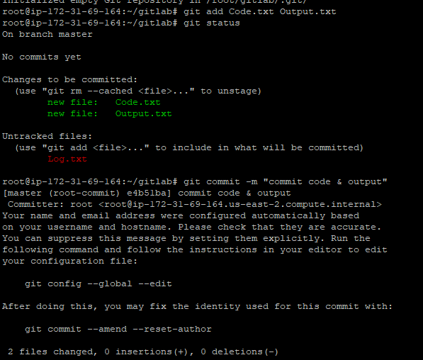
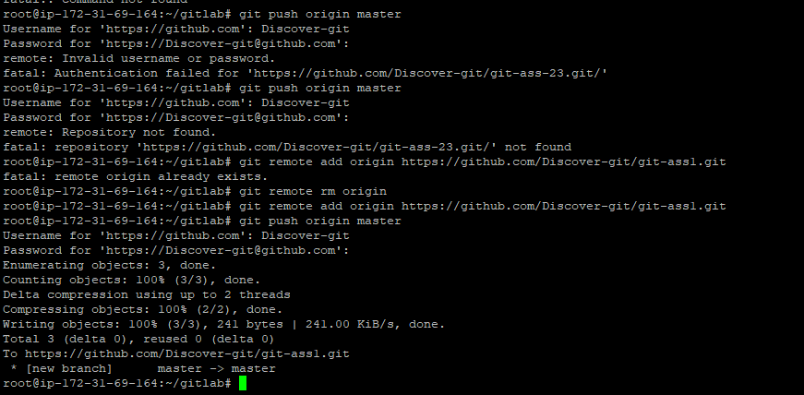
==================================================================================
Assignment 2 – Git
root@ip-172-31-69-164:~# mkdir git
root@ip-172-31-69-164:~# cd git
root@ip-172-31-69-164:~/git# touch feature1.txt feature2.txt
root@ip-172-31-69-164:~/git# git add . && git commit -m "commit master"
fatal: not a git repository (or any of the parent directories): .git
root@ip-172-31-69-164:~/git# git init
Initialized empty Git repository in /root/git/.git/
root@ip-172-31-69-164:~/git# git add . && git commit -m "commit master"
[master (root-commit) 3fcd293] commit master
Committer: root <root@ip-172-31-69-164.us-east-2.compute.internal>
Your name and email address were configured automatically based
on your username and hostname. Please check that they are accurate.
You can suppress this message by setting them explicitly. Run the
following command and follow the instructions in your editor to edit
your configuration file:

git config --global --edit

After doing this, you may fix the identity used for this commit with:

git commit --amend --reset-author

2 files changed, 0 insertions(+), 0 deletions(-)
create mode 100644 feature1.txt
create mode 100644 feature2.txt
root@ip-172-31-69-164:~/git# git checkout -b develop
Switched to a new branch 'develop'
root@ip-172-31-69-164:~/git# git checkout -b feature1
Switched to a new branch 'feature1'
root@ip-172-31-69-164:~/git# git checkout -b feature2
Switched to a new branch 'feature2'
root@ip-172-31-69-164:~/git# git checkout develop
Switched to branch 'develop'
root@ip-172-31-69-164:~/git# touch develop.txt
root@ip-172-31-69-164:~/git# git stash apply develop.txt
error: develop.txt is not a valid reference
root@ip-172-31-69-164:~/git# git stash apply
No stash entries found.
root@ip-172-31-69-164:~/git# git checkout feature1
Switched to branch 'feature1'
root@ip-172-31-69-164:~/git# touch new.txt
root@ip-172-31-69-164:~/git# git add new.txt && git commit -m "commit feature B"
[feature1 3b3c258] commit feature B
Committer: root <root@ip-172-31-69-164.us-east-2.compute.internal>
Your name and email address were configured automatically based
on your username and hostname. Please check that they are accurate.
You can suppress this message by setting them explicitly. Run the
following command and follow the instructions in your editor to edit
your configuration file:

git config --global --edit

After doing this, you may fix the identity used for this commit with:

git commit --amend --reset-author

1 file changed, 0 insertions(+), 0 deletions(-)
create mode 100644 new.txt
root@ip-172-31-69-164:~/git# git checkout develop
Switched to branch 'develop'
root@ip-172-31-69-164:~/git# git stash pop
No stash entries found.
root@ip-172-31-69-164:~/git# git add develop.txt && git commit -m "commit develop B"
[develop f1798d7] commit develop B
Committer: root <root@ip-172-31-69-164.us-east-2.compute.internal>
Your name and email address were configured automatically based
on your username and hostname. Please check that they are accurate.
You can suppress this message by setting them explicitly. Run the
following command and follow the instructions in your editor to edit
your configuration file:

git config --global --edit

After doing this, you may fix the identity used for this commit with:

git commit --amend --reset-author

1 file changed, 0 insertions(+), 0 deletions(-)
create mode 100644 develop.txt
root@ip-172-31-69-164:~/git# git checkout feature1
==========================================================================================
Assignment 3 – Git

root@ip-172-31-69-164:~# mkdir master
root@ip-172-31-69-164:~# cd master/
root@ip-172-31-69-164:~/master# touch main.txt
root@ip-172-31-69-164:~/master# git init
Initialized empty Git repository in /root/master/.git/
root@ip-172-31-69-164:~/master# git add . && git commit -m "commit master"
[master (root-commit) 3af01ca] commit master
Committer: root <root@ip-172-31-69-164.us-east-2.compute.internal>
Your name and email address were configured automatically based
on your username and hostname. Please check that they are accurate.
You can suppress this message by setting them explicitly. Run the
following command and follow the instructions in your editor to edit
your configuration file:

git config --global --edit

After doing this, you may fix the identity used for this commit with:

git commit --amend --reset-author

1 file changed, 0 insertions(+), 0 deletions(-)
create mode 100644 main.txt
root@ip-172-31-69-164:~/master# git checkout -b develop
Switched to a new branch 'develop'
root@ip-172-31-69-164:~/master# touch develop.txt
root@ip-172-31-69-164:~/master# git add develop.txt && git commit -m "commit develop"
[develop bb9e797] commit develop
Committer: root <root@ip-172-31-69-164.us-east-2.compute.internal>
Your name and email address were configured automatically based
on your username and hostname. Please check that they are accurate.
You can suppress this message by setting them explicitly. Run the
following command and follow the instructions in your editor to edit
your configuration file:

git config --global --edit

After doing this, you may fix the identity used for this commit with:

git commit --amend --reset-author

1 file changed, 0 insertions(+), 0 deletions(-)
create mode 100644 develop.txt
root@ip-172-31-69-164:~/master# git checkout -b f1
Switched to a new branch 'f1'
root@ip-172-31-69-164:~/master# touch f1.txt
root@ip-172-31-69-164:~/master# git add f1 && git commit -m "commit f1"
fatal: pathspec 'f1' did not match any files
root@ip-172-31-69-164:~/master# git add f1.txt && git commit -m "commit f1"
[f1 519b16c] commit f1
Committer: root <root@ip-172-31-69-164.us-east-2.compute.internal>
Your name and email address were configured automatically based
on your username and hostname. Please check that they are accurate.
You can suppress this message by setting them explicitly. Run the
following command and follow the instructions in your editor to edit
your configuration file:

git config --global --edit

After doing this, you may fix the identity used for this commit with:

git commit --amend --reset-author

1 file changed, 0 insertions(+), 0 deletions(-)
create mode 100644 f1.txt
root@ip-172-31-69-164:~/master# git chekout -b f2
git: 'chekout' is not a git command. See 'git --help'.

The most similar command is
checkout
root@ip-172-31-69-164:~/master# git checkout -b f2
Switched to a new branch 'f2'
root@ip-172-31-69-164:~/master# touch f2.txt
root@ip-172-31-69-164:~/master# git add f2.txt && git commit -m "commit f2"
[f2 cabfbf1] commit f2
Committer: root <root@ip-172-31-69-164.us-east-2.compute.internal>
Your name and email address were configured automatically based
on your username and hostname. Please check that they are accurate.
You can suppress this message by setting them explicitly. Run the
following command and follow the instructions in your editor to edit
your configuration file:

git config --global --edit

After doing this, you may fix the identity used for this commit with:

git commit --amend --reset-author

1 file changed, 0 insertions(+), 0 deletions(-)
create mode 100644 f2.txt
root@ip-172-31-69-164:~/master# git branch
develop
f1
* f2
master
root@ip-172-31-69-164:~/master# git remote add origin https://github.com/Discover-git/git-ass3.git
root@ip-172-31-69-164:~/master# git push origin --all
Username for 'https://github.com': Discover-git
Password for 'https://Discover-git@github.com':
Enumerating objects: 9, done.
Counting objects: 100% (9/9), done.
Delta compression using up to 2 threads
Compressing objects: 100% (7/7), done.
Writing objects: 100% (9/9), 780 bytes | 780.00 KiB/s, done.
Total 9 (delta 3), reused 0 (delta 0)
remote: Resolving deltas: 100% (3/3), done.
To https://github.com/Discover-git/git-ass3.git
* [new branch] develop -> develop
* [new branch] f1 -> f1
* [new branch] f2 -> f2
* [new branch] master -> master
root@ip-172-31-69-164:~/master# git checkout master
Switched to branch 'master'
root@ip-172-31-69-164:~/master# git branch -D f2
Deleted branch f2 (was cabfbf1).
root@ip-172-31-69-164:~/master# git branch
develop
f1
* master
root@ip-172-31-69-164:~/master# git push origin -d f2
Username for 'https://github.com': Discover-git
Password for 'https://Discover-git@github.com':
To https://github.com/Discover-git/git-ass3.git
- [deleted] f2
root@ip-172-31-69-164:~/master#

Assignment 4 – Git

root@ip-172-31-69-164:~# mkdir ga4
root@ip-172-31-69-164:~# cd ga4
root@ip-172-31-69-164:~/ga4# ls
root@ip-172-31-69-164:~/ga4# touch master.txt
root@ip-172-31-69-164:~/ga4# git init
Initialized empty Git repository in /root/ga4/.git/
root@ip-172-31-69-164:~/ga4# git add . && git commit -m "master commit"
[master (root-commit) 580fd0d] master commit
Committer: root <root@ip-172-31-69-164.us-east-2.compute.internal>
Your name and email address were configured automatically based
on your username and hostname. Please check that they are accurate.
You can suppress this message by setting them explicitly. Run the
following command and follow the instructions in your editor to edit
your configuration file:

git config --global --edit

After doing this, you may fix the identity used for this commit with:

git commit --amend --reset-author

1 file changed, 0 insertions(+), 0 deletions(-)
create mode 100644 master.txt
root@ip-172-31-69-164:~/ga4# git branch public1
root@ip-172-31-69-164:~/ga4# git branch public2
root@ip-172-31-69-164:~/ga4# git branch private
root@ip-172-31-69-164:~/ga4# git checkout public1
Switched to branch 'public1'
root@ip-172-31-69-164:~/ga4# touch public1.txt
root@ip-172-31-69-164:~/ga4# git add public1.txt && git commit -m "commit public"
[public1 403ff1c] commit public
Committer: root <root@ip-172-31-69-164.us-east-2.compute.internal>
Your name and email address were configured automatically based
on your username and hostname. Please check that they are accurate.
You can suppress this message by setting them explicitly. Run the
following command and follow the instructions in your editor to edit
your configuration file:

git config --global --edit

After doing this, you may fix the identity used for this commit with:

git commit --amend --reset-author

1 file changed, 0 insertions(+), 0 deletions(-)
create mode 100644 public1.txt
root@ip-172-31-69-164:~/ga4# git checkout master
Switched to branch 'master'
root@ip-172-31-69-164:~/ga4# git merge public1
Updating 580fd0d..403ff1c
Fast-forward
public1.txt | 0
1 file changed, 0 insertions(+), 0 deletions(-)
create mode 100644 public1.txt
root@ip-172-31-69-164:~/ga4# git merge public2
Already up to date.
root@ip-172-31-69-164:~/ga4# git checkout private
Switched to branch 'private'
root@ip-172-31-69-164:~/ga4# nano master.txt
root@ip-172-31-69-164:~/ga4# git add master.txt && git commit -m "commit private"
[private 671639d] commit private
Committer: root <root@ip-172-31-69-164.us-east-2.compute.internal>
Your name and email address were configured automatically based
on your username and hostname. Please check that they are accurate.
You can suppress this message by setting them explicitly. Run the
following command and follow the instructions in your editor to edit
your configuration file:

git config --global --edit

After doing this, you may fix the identity used for this commit with:

git commit --amend --reset-author

1 file changed, 1 insertion(+)
root@ip-172-31-69-164:~/ga4# git checkout public1
Switched to branch 'public1'
root@ip-172-31-69-164:~/ga4# git merge private
Merge made by the 'recursive' strategy.
master.txt | 1 +
1 file changed, 1 insertion(+)
root@ip-172-31-69-164:~/ga4# git checkout public2
Switched to branch 'public2'
root@ip-172-31-69-164:~/ga4# git merge private
Updating 580fd0d..671639d
Fast-forward
master.txt | 1 +
1 file changed, 1 insertion(+)
root@ip-172-31-69-164:~/ga4# git branch
* master
private
public1
public2
root@ip-172-31-69-164:~/ga4# touch new.txt
root@ip-172-31-69-164:~/ga4# git add . && git commit -m "commit mas"
[master bc45a46] commit mas
Committer: root <root@ip-172-31-69-164.us-east-2.compute.internal>
Your name and email address were configured automatically based
on your username and hostname. Please check that they are accurate.
You can suppress this message by setting them explicitly. Run the
following command and follow the instructions in your editor to edit
your configuration file:

git config --global --edit

After doing this, you may fix the identity used for this commit with:

git commit --amend --reset-author

1 file changed, 0 insertions(+), 0 deletions(-)
create mode 100644 new.txt
root@ip-172-31-69-164:~/ga4# git checkout private
Switched to branch 'private'
root@ip-172-31-69-164:~/ga4# git merge master
Updating 671639d..bc45a46
Fast-forward
new.txt | 0
public1.txt | 0
2 files changed, 0 insertions(+), 0 deletions(-)
create mode 100644 new.txt
create mode 100644 public1.txt
root@ip-172-31-69-164:~/ga4#

Assignment 5 – Git
197 mkdir git-workflow
198 cd git-workflow/
199 git init
200 git branch
201 git checkout -b develop
202 git checkout -b feature
203 git checout -b hotfix
204 git checkout -b hotfix
205 git checkout feature
206 git branch
207 git checkout -b feature
208 touch feature.txt
209 git add .
210 git commit -m "feature commit to fea"
211 git checkout develop
212 git checkout -b develop
213 git merge feature
214 git checkout master
215 git checkout -b master
216 git merge develop
217 git checkout -b hotfix-ungent
218 touch urgent.txt
219 git checkout master
220 git merge hotfix-ungent
221 git branch
222 ls
223 git push origin develop
224 git remote add origin https://github.com/GitHubvenkat1/5th-assignment.git
225 git push origin develop
226 git push origin master
227 cd ..
228 cd git-workflow/
229 git push origin -d master
230 git push origin -d develop
231 git branch -D develop
232 git push origin -d develop
233 cd ..
234 rm -r git-workflow
235 mkdir workflow
236 cd workflow/
237 touch test.txt && git add . && git commit -m "master commit"
238 git init
239 touch test.txt && git add . && git commit -m "master commit"
240 git branch develop
241 git branch feature
242 git branch hotfix
243 git checkout feature
244 touch feature.txt && git add . && git commit -m "feature commit #3"
245 git checkout develop
246 git merge feature
247 git checkout master
248 git merge develop
249 git checkout -b hotfix-urgent
250 touch urgent.txt
251 git checkout master
252 git merge hotfix-urgent
253 git remote add origin https://github.com/GitHubvenkat1/assign5.git
254 git push origin develop
255 git push origin master

